React Native CLI:

* Install Chocolatey copy command from website
  + Open window powershell and paste it
* Install Node JS and JDK
  + Choco install –y nodejs .install open jdk8
* Download and install Android Studio
  + Android studio Configuration
    - Go to android studio
    - Go to Configure and then go to SDK manager and check mark on “show package details
    - Under android 10.0 Q check mark android SDK platform 29,intel X86……. And intel x64 then click apply and install SDK
    - Next select SDK tools and check show package details check mark on 29.0.2 and click on apply and install
* After configuration press window button and search for “environment variable” and select it
* Go to environment variables and select new now type in User variable

variable name=ANDROID_HOME and

variable value=C:\Users\welcome\AppData\Local\Android\Sdk

* Go to environment variables and select new now type in System variable

variable name=ANDROID_HOME and

variable value=C:\Users\welcome\AppData\Local\Android\Sdk

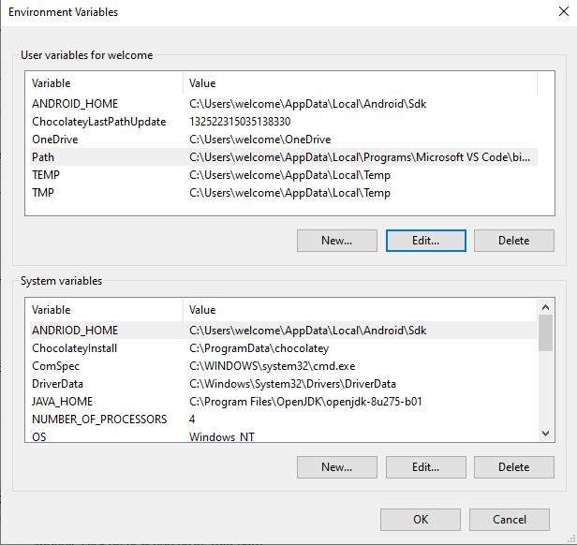

* Go to the following path

C:\Users\welcome\AppData\Local\Android\Sdk\platforms

Copy that path and go to environment variables and double click on path which is in user variable click on new and paste that path

* Similarly add build tool path, emulator path, and SDK tools

